# Assignment-UML Parser Test Cases

1. Source Code in GitHub

<https://github.com/nguyensjsu/cmpe202-supriyasethi/tree/master/umlparser>

1. Instructions to Run UmlParser

* Clone umlparser to your local system

*git clone* [*https://github.com/nguyensjsu/cmpe202-supriyasethi.git*](https://github.com/nguyensjsu/cmpe202-supriyasethi.git)

* Go to folder umlparser\target and run umlparser.jar file using below instructions. Open terminal in folder and execute below commands.

*cd umlparser\target*

*umlparser.jar <source folder> <output file name>*

**umlparser.jar** – UmlParser main class to execute the parser

**source folder** – Path to input java source files. In this project, we can use umlparser\default folder to keep java source files.

**output file name** – Path to output class diagram to be created. Please provide the “.png” extension in the end of file name in the path. For example, for test1 case, please provide output file name as umlparser\test1.png if UML diagram is required to be generated in umlparser folder.

*umlparser.jar umlparser\default umlparser\test1.png*

* The diagram will be created in the path provided in **output file name**.

1. Below are the images of 5 UML diagrams created by UmlParser project. The images are saved in path umlparser\umltestdiagram

test1

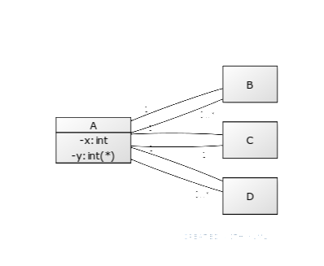

test2

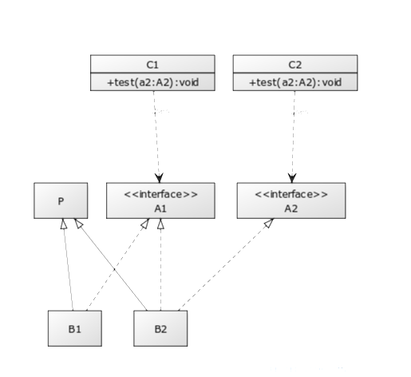

test3

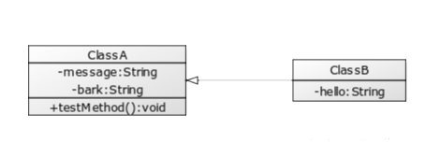

test4

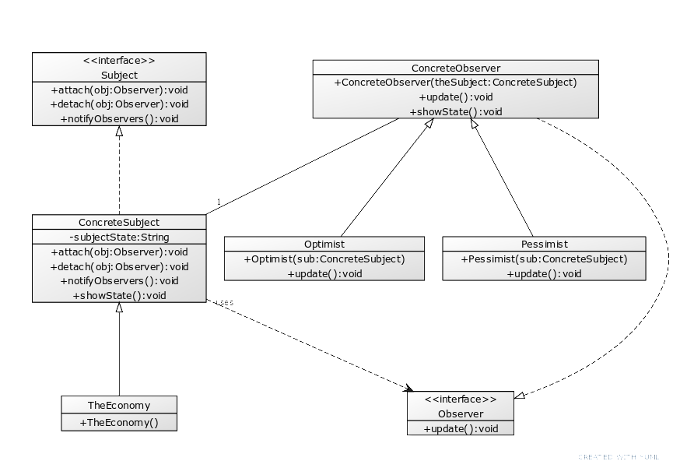

test5

